Quiz Game Buzzers: Are You Smarter Than Mr. Scaillo?

In the developed project, “guizero” library of python programming language is use.

>> pip install guizero

When the user runs the code, following screen appears:

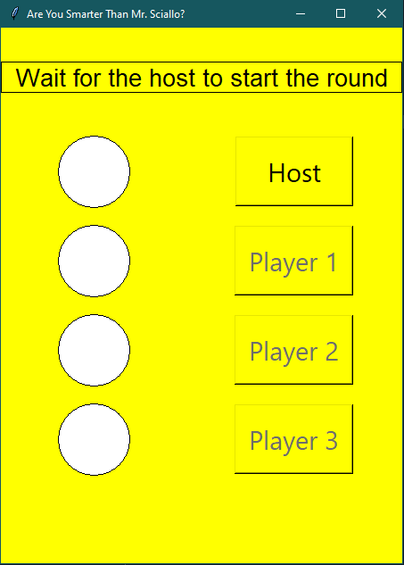

When the host presses the button, the lights color change as follows:

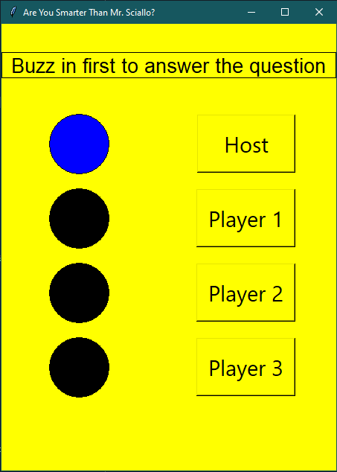

If the quiz is started and host has asked the question, any player can quickly press the assigned button. As soon as the first person presses the button, all other players’ button get disabled and the light of the person who pressed it first turns green.

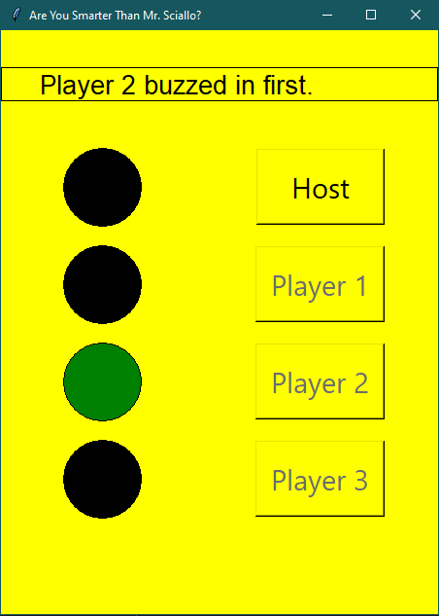

The process goes on.

In the code:

I created 4 functions, one for each button, named:

1. host
2. player1
3. player2
4. player3

Screen size: 450x600

Background color: Yellow (Can set it according to your choice by changing bg value in code line # 74)

Text size: 22px

Comments added in the functions and next to code lines where needed.